GARUDA: Quantum Defense System
GARUDA is a cutting-edge, real-time WiFi network security scanner and threat assessment platform. It offers a comprehensive cybersecurity solution designed for robust network monitoring and protection against the evolving landscape of digital threats. This document provides an in-depth overview of GARUDA's capabilities, architecture, and applications, tailored for IT security students, network administrators, and technical stakeholders.

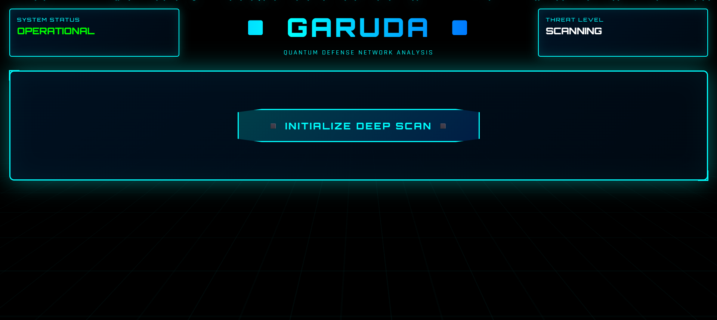

Introducing the Visionary Team Behind GARUDA
The development of GARUDA, a sophisticated network security platform, was spearheaded by a dedicated team committed to advancing cybersecurity. Their collective expertise and innovative approach have been instrumental in creating a system that promises to redefine network defense.
1

K. Anoop
Roll Number: 2420030503
2

V. Dhruva Sai
Roll Number: 2420030009
3

P. Akhil Kumar Reddy
Roll Number: 2420030496
4

B. Bhavya Sai Sri
Roll Number: 2420030594
5

P. Lahari
Roll Number: 2420030552

"Guided by: SHAIK ASIF SIR"

This diverse team brought together a wealth of knowledge and a shared vision to create a robust and intelligent threat detection system. Their efforts under the guidance of SHAIK ASIF SIR have culminated in GARUDA, a testament to collaborative innovation in cybersecurity.

System Overview: GARUDA's Core Capabilities
GARUDA stands as a sophisticated network security scanning and assessment platform, engineered to defend against the complexities of modern cyber threats. Its primary objective is to safeguard users from Man-in-the-Middle (MITM) attacks and unauthorized network access through intelligent threat detection and continuous real-time monitoring.
Cross-Platform Detection
GARUDA offers seamless operation across major operating systems including Windows, macOS, and Linux, ensuring broad applicability and accessibility for diverse IT environments.
Real-Time Assessment
The platform provides continuous vulnerability analysis, offering up-to- the-minute insights into network security posture and potential weak points.
Device Discovery
GARUDA is adept at identifying all connected devices on a network, crucial for pinpointing unauthorized access or suspicious entities within the infrastructure.

This comprehensive approach ensures that GARUDA not only identifies threats but also provides the necessary data for proactive network management and security enhancement.

Core Features: Unpacking GARUDA's Functionality
GARUDA integrates a suite of powerful features designed to provide unparalleled visibility and control over WiFi network security. Each component plays a vital role in its holistic defense strategy.




WiFi Network Scanning
Detects nearby networks, providing essential details like encryption type, signal strength, and BSSID across all major operating systems for comprehensive visibility.

Security Assessment
Performs real-time threat analysis based on encryption standards, evaluates MITM risk, and classifies vulnerabilities to prioritize immediate security actions.

Device Discovery
Utilizes ping sweep technology and ARP table analysis to identify all devices connected to your network, enabling early detection of unauthorized connections.

Ÿraffic Monitoring
Tracks bytes and packets sent/received, offering real-time network traffic analysis and statistics to detect unusual activity or potential data breaches.

These features combine to form a robust defense system, providing network administrators with the tools needed to maintain a secure and efficient network environment.

Security Threat Assessment: GARUDA's Classification System
GARUDA employs a sophisticated five-tier classification system to assess and categorize network security risks. This system is based on an in-depth analysis of encryption standards and the probability of exploitation, providing clear and actionable insights.

Critical 4 Open/WEP

1
Networks with open or WEP encryption are deemed critically vulnerable, requiring immediate action due to high susceptibility to attacks.

High 4 WPA
WPA networks are classified as high risk, indicating a significant vulnerability to various attack vectors, and warranting prompt attention.
2

Medium 4 WPA2-PSK
WPA2-PSK networks carry a moderate risk level. While more secure than WPA, they can still be exploited, necessitating regular monitoring.
3

Low 4 WPA2-Enterprise
WPA2-Enterprise networks offer a lower risk profile due to their robust modern encryption standards, providing enhanced protection.
4

Secure 4 WPA3
WPA3 represents the pinnacle of current WiFi security, providing the highest level of protection and resilience against known threats.
5

Technical Architecture: The Engine Behind GARUDA
GARUDA's robust architecture is designed for efficiency, scalability, and cross-platform compatibility, leveraging modern web and backend technologies to deliver a seamless user experience and powerful security analysis.

Backend (Python)
Flask REST API server for robust data handling.
Cross-platform compatibility ensures broad operational reach.
CORS enabled for secure client-server communication.
Ping sweep network scanning for efficient device detection.
ARP table parsing for comprehensive device enumeration.
Native OS command integration (netsh, airport, nmcli) for granular control.

Frontend (Web)
Responsive HTML5/CSS3 for optimal viewing across devices.
JavaScript client application for dynamic interaction.
Real-time data updates keep users informed with current threat intelligence.
Professional UI design prioritizing clarity and ease of use.
Mobile and desktop optimized for diverse user needs.
Single-page application (SPA) architecture for a fluid experience.

The backend handles the heavy lifting of network scanning and analysis, while the frontend provides an intuitive interface for users to interact with the system and visualize security data.

Scanning Methods

Ping Sweep
Fast parallel scanning of entire subnets using ICMP echo requests to identify active hosts.

ARP Table
Comprehensive device enumeration by analyzing the Address Resolution Protocol cache for connected entities.

Native OS Commands
Leverages OS-specific tools like Windows (netsh), macOS (airport), and Linux (nmcli) for precise network data retrieval.

API Specification: Interfacing with GARUDA
GARUDA's RESTful API provides a robust interface for programmatic access to comprehensive network security data and device topology. This allows for integration with other security tools and custom applications.

GET /api/health Performs a system health check and verifies operational status, ensuring the
GARUDA backend is functioning
correctly.

GET /api/scan/connected Retrieves information about currently connected networks and provides a
security assessment based on identified
vulnerabilities.

GET /api/scan/nearby
Scans for nearby WiFi networks, returning detailed information on encryption, security protocols, and signal strength.

POST /api/scan/full
Initiates a comprehensive network scan, including device discovery and an in- depth threat analysis of the entire network.

All API endpoints consistently return JSON responses, featuring detailed security information and a clear representation of the network's device topology. This standardization facilitates easy parsing and integration into various security workflows.

User Interface Components: GARUDA's Intuitive Dashboard
GARUDA's user interface is meticulously designed for clarity, responsiveness, and intuitive navigation, making complex network security data accessible to both novices and seasoned professionals.

HUD Header
Displays critical system status, current security level, and real-time operational information at a glance.

Scan Control Panel
Provides one-click network scanning functionality with clear progress tracking, simplifying the initiation of security assessments.

Results Grid
Presents detailed scan outcomes including detected nodes, identified threats, scan duration, and all scanned addresses in an organized tabular format.

Device Topology
Visualizes the network's structure, showing the gateway node, the current device, connected devices, and active traffic patterns.

Threat Alerts
Delivers real-time vulnerability detection and risk assessments, providing immediate notifications for critical security events.
The design approach focuses on a professional interface with a clean visual hierarchy responsive

Recommendations
Offers actionable security guidelines, prioritized by severity, to guide users in mitigating identified risks
effectively.

Security Capabilities: Advanced Threat Detection & Risk Assessment
GARUDA is equipped with a comprehensive suite of security capabilities designed to provide deep insights into network vulnerabilities and proactive threat mitigation strategies.

Advanced Threat Detection
Man-in-the-Middle (MITM) attack vulnerability assessment for critical threat identification.
Encryption strength analysis coupled with exploitation probability to quantify risks.
Network anomaly detection and device profiling to spot unusual behavior.
Unauthorized access point identification, preventing rogue devices from compromising security.
Open port scanning and service identification to expose potential attack vectors.

Risk Assessment Features
Automated threat classification and severity rating for prioritized response.
Device vendor identification via MAC address lookup for better asset management.
Real-time traffic pattern analysis and monitoring to detect suspicious flows.
Network segmentation recommendations for enhanced isolation and security.
Compliance and security posture reporting to meet regulatory requirements.

\
These combined features ensure GARUDA provides a holistic view of network security, enabling administrators to make informed decisions and maintain a resilient defense against cyber threats.

System Requirements & Setup: Getting Started with GARUDA
Deploying GARUDA is straightforward, requiring minimal prerequisites and offering flexible deployment options to suit various operational environments.

Software Requirements

Python 3.7+ is essential for the backend operations.
Flask web framework and Flask-CORS extension for API functionality.
A modern web browser (Chrome, Firefox, Safari, Edge) for the frontend interface.

OS-Specific Tools
Windows
Requires the built-in netsh command for network configurations.
macOS
Utilizes the built-in Airport utility for WiFi management.
Linux
Relies on NetworkManager and nmcli for network interactions.
Deployment Architecture
GARUDA supports both local and cross-platform deployments. The backend API runs on port 5000, while the frontend operates as a standalone HTML application.

Installation Guide
Get GARUDA running in three simple steps:
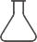
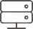


Install Python Dependencies

pip install flask flask-cors
Start Backend Server
python garuda_backend.py
The backend server will start on
with cross-origin requests enabled by default for local testing.
http://127.0.0.1:5000

Open Frontend Application
Open index.html in your preferred web browser to access the GARUDA interface.

Output:
